Gratefully Celebrating 25 Years!!! Thanksgiving 2023 1,612 Turkey Baskets!!! Blessed Be God, Now & Forever!!!
“Only the aged and those who cannot pay their bills truly understand how important a holiday meal can be when you are separated from those you love and don’t have the money to do an elaborate dinner.
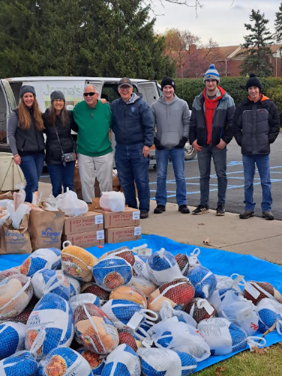
All of you who gave tirelessly to the Turkey Drive have understood the needs of the lonely and impoverished. THANK YOU, THANK YOU, THANK YOU for being My Hands and in packing and transporting food to the needy! I will come when you call and answer every one of your needs. Do not be afraid.
Jesus Christ, the Son of the Living God whom we thank with all our heart for the great return of bountifulness to the people who so desperately needed your giving.
The Drive was a tremendous success, and we achieved a pinnacle that we hadn’t before. To the merchants, the Turkey Trotters, the drivers, and those who distributed the food, may God richly shower you abundantly with His Gratefulness.
I, Jesus Christ, proclaim you all greater than the Pharisees; as lovers of My Sacred Heart, which once again has reached out and gratified all who took part in My Bounty. Amen.” December 9, 2023, Feast of St. Juan Diego
Highlights: 242 Turkey Baskets were delivered to the Nigerian Nuns, who had in-need families from Metro Detroit arrive within an hour on 11-17, 11- 20, 11-21 and experience a beautiful Thanksgiving.
Rebecca picked up the torch and delivered 15 Turkey Baskets into her deceased parents’ neighborhood with her nephew after helping her father, Ray, go door to door for several years.
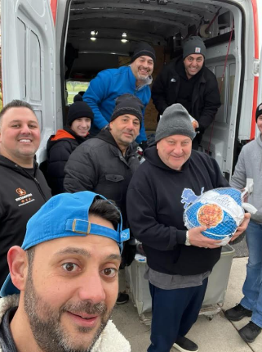
We are deeply indebted to Hispanic Outreach and Baldwin Clothes Closet Clients for accompanying Daily Apostle in our mission of providing 25 years of delivering Thanksgiving Turkey Baskets to the needy. And to the core group of donors and workers that have been with us for 17 years in our attempt to provide a sumptuous meal to the thousands who needed it.
Dear Daily Apostle,

There are not enough words to express our gratitude for the Thanksgiving dinners. Our 27 client families were beyond thankful for the gesture and the extra special items that were included in the Baskets. I heard clients repeatedly say they would not have been able to afford the meal without the help. Again, they were so grateful for the help when these times are so hard for a lot of our clients, struggling to put food on their tables each day.

Thank you for shining the light of Christ on our clients with these meals. God Bless you and all the many hands it took to prepare and deliver the dinners.

Wishing you a very blessed Christmas and New Year!

With a grateful heart.

Laurie Shults
Client Services Director.
Bella Women's Center – Owosso, MI

